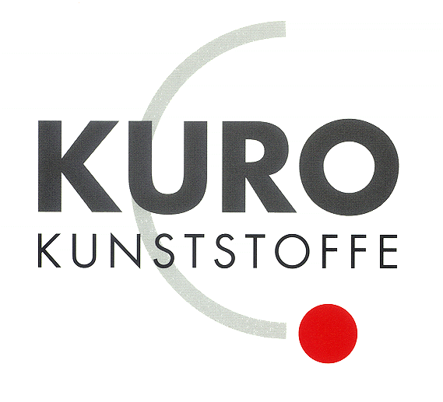

KURO – Information for invitation to tender

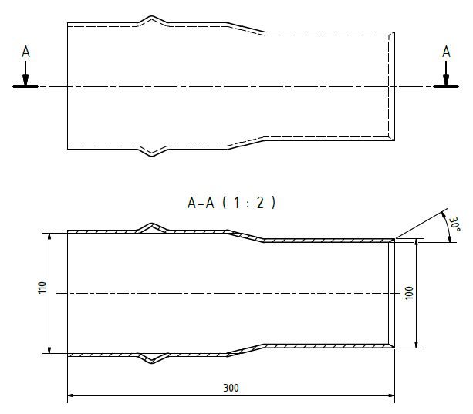

Product:

PVC transition to cable shape stone

Information for invitation to tender:

 | Pos:....................... | PVC transition to cable shape stone  Plain end bevelled
From integral seal socket to cable shape stone
Colour: black / 110 x 100 mm
 |  | System KURO o. glw. (www.kuro-kunststoffe.de),
 |  | supply and install, as an addition to pos: ...........
 |  | Amount:............Pieces UP: ....... TP: ........

 | Pos:....................... | PVC transition to cable shape stone  Plain end bevelled
From solvent welded socket to cable shape stone
Colour: black / 110 x 100 mm
 |  | System KURO o. glw. (www.kuro-kunststoffe.de),
 |  | supply and install, as an addition to pos: ...........
 |  | Amount:............Pieces UP: ....... TP: ........
 | Pos:....................... | PVC transition to cable shape stone  Plain end bevelled
From integral seal socket to cable shape stone
Colour: black / 126 x 120 mm
 |  | System KURO o. glw. (www.kuro-kunststoffe.de),
 |  | supply and install, as an addition to pos: ...........
 |  | Amount:............Pieces UP: ....... TP: ........

